Street Sense

You are ultimately responsible for your own safety.

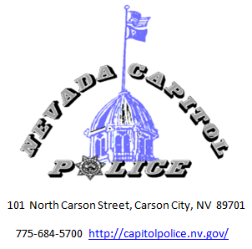

Personal Safety Basics
Stay alert to your surroundings.
- Know who is around you.
- Don’t be preoccupied.
Plan where you are going before you go.
- Avoid Low Light areas and alleyways.
- Stay in well populated areas.
Use your instincts and intuition.
- Intuition is reading the signals we give ourselves.
- Intuition is always right in two ways:
- It is always in response to something.
- It always has your best interest at heart.
- If you feel uneasy about a situation – avoid it.
Project a confident image.
- Walk with confidence (firm and steady pace).
- Look people in the eye when you pass them.

Street Sense Tips

- Keep zippers and snaps closed on purses or bags.
- Hold your purse/briefcase tight and keep it close to your body – not towards your back.
- Carry your purse/briefcase towards the building side of the sidewalk not the street side.
- The more packages you carry, the more vulnerable you are.
- If a driver stops to ask directions, avoid getting near their vehicle.
- Avoid strangers that contact you first.
- When someone tries to stop you – keep walking. Don’t give them money or talk to them.
- If they are persistent, then LOUDLY tell them to leave you alone and walk away.

